Aim: To implement an ANOVA Test

Theory:
Q1. What is ANOVA? (Analysis of Variance)
A statistical test that compares the means of three or more groups to see if at least one is different. It works by comparing variance between groups to variance within groups.

Q2. What is the F-test?
The specific test statistic used in ANOVA. It's a ratio:
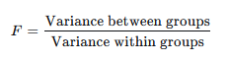
A large F value (much greater than 1) suggests group means are not equal.

Q3. What is the relationship between ANOVA and linear regression?
They are mathematically identical. ANOVA is a special case of linear regression where the predictor variables are categorical (e.g., treatment groups).
Running ANOVA on group means gives the same p-value as running regression with dummy-coded group variables.

Q4. Write a Python program to implement an ANOVA test.
Code:
import scipy.stats as stats

group1 = [21, 24, 22, 23, 25]
group2 = [28, 27, 30, 29, 31]
group3 = [18, 20, 19, 22, 21]

f_stat, p_value = stats.f_oneway(group1, group2, group3)

print(f"F-statistic: {f_stat:.4f}")
print(f"P-value: {p_value:.4f}")

alpha = 0.05
if p_value < alpha:
print("Reject H0: At least one group mean is different.")
else:
print("Fail to reject H0: No significant difference between group means.")

Output:
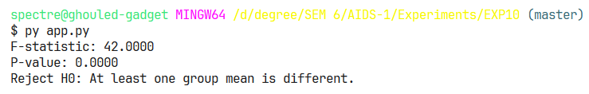

Conclusion:
Successfully implemented Linear Regression in Python.

